Chapter 2, Problem 62.

A three-wire system supplies two loads A and B as shown in Fig. 2.125. Load A consists of a motor drawing a current of 8 A, while load B is a PC drawing 2 A. Assuming 10 h/day of use for 365 days and 6 cents/kWh, calculate the annual energy cost of the system.

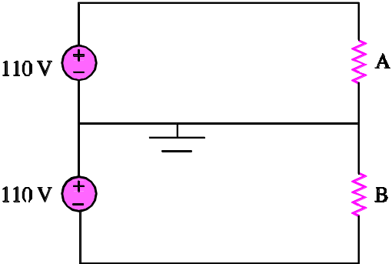

Figure 2.125
For Prob. 2.62.

